

AP® Physics C
1991 Free response Questions

The materials included in these files are intended for use by AP teachers for course and exam preparation in the classroom; permission for any other use must be sought from the Advanced Placement Program®. Teachers may reproduce them, in whole or in part, in limited quantities, for face-to-face teaching purposes but may not mass distribute the materials, electronically or otherwise. These materials and any copies made of them may not be resold, and the copyright notices must be retained as they appear here. This permission does not apply to any third-party copyrights contained herein.

These materials were produced by Educational Testing Service® (ETS®), which develops and administers the examinations of the Advanced Placement
Program for the College Board. The College Board and Educational Testing Service (ETS) are dedicated to the principle of equal opportunity, and their
programs, services, and employment policies are guided by that principle.

The College Board is a national nonprofit membership association dedicated to preparing, inspiring, and connecting students to college and opportunity.
Founded in 1900, the association is composed of more than 4,200 schools, colleges, universities, and other educational organizations. Each year, the
College Board serves over three million students and their parents, 22,000 high schools, and 3,500 colleges, through major programs and services in
college admission, guidance, assessment, financial aid, enrollment, and teaching and learning. Among its best-known programs are the SAT®, the
PSAT/NMSQT®, and the Advanced Placement Program® (AP®). The College Board is committed to the principles of equity and
excellence, and that commitment is embodied in all of its programs, services, activities, and concerns.

APIEL is a trademark owned by the College Entrance Examination Board. PSAT/NMSQT is a registered trademark jointly owned by the College Entrance Examination Board and the National Merit Scholarship Corporation. Educational Testing Service and ETS are registered trademarks of Educational Testing Service.
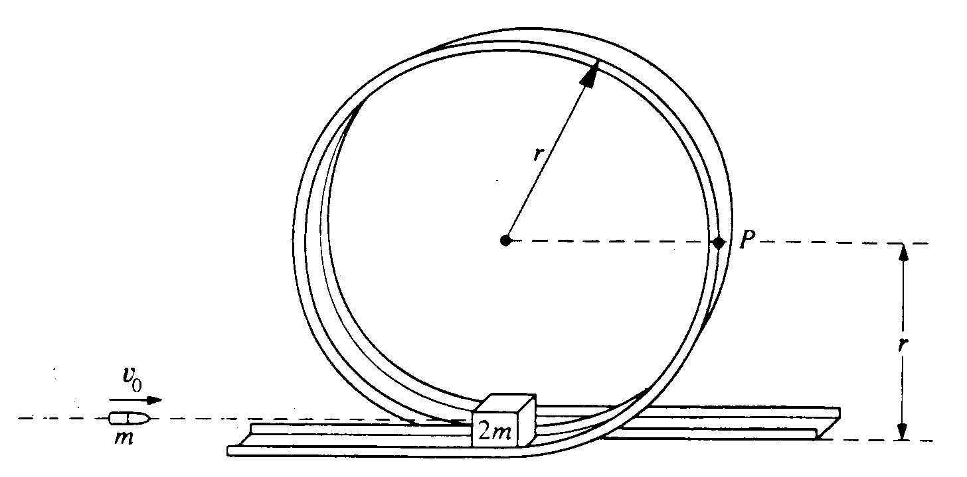
1991M1. A small block of mass 2m initially rests on a track at the bottom of the circular, vertical loop-the-loop shown above, which has a radius r. The surface contact between the block and the loop is frictionless. A bullet of mass m strikes the block horizontally with initial speed v_{o} and remains embedded in the block as the block and bullet circle the loop. Determine each of the following in terms of m, v₀ r, and g.
a. The speed of the block and bullet immediately after impact
b. The kinetic energy of the block and bullet when they reach point P on the loop
c. The minimum initial speed v_{min} of the bullet if the block and bullet are to successfully execute a complete circuit of the loop
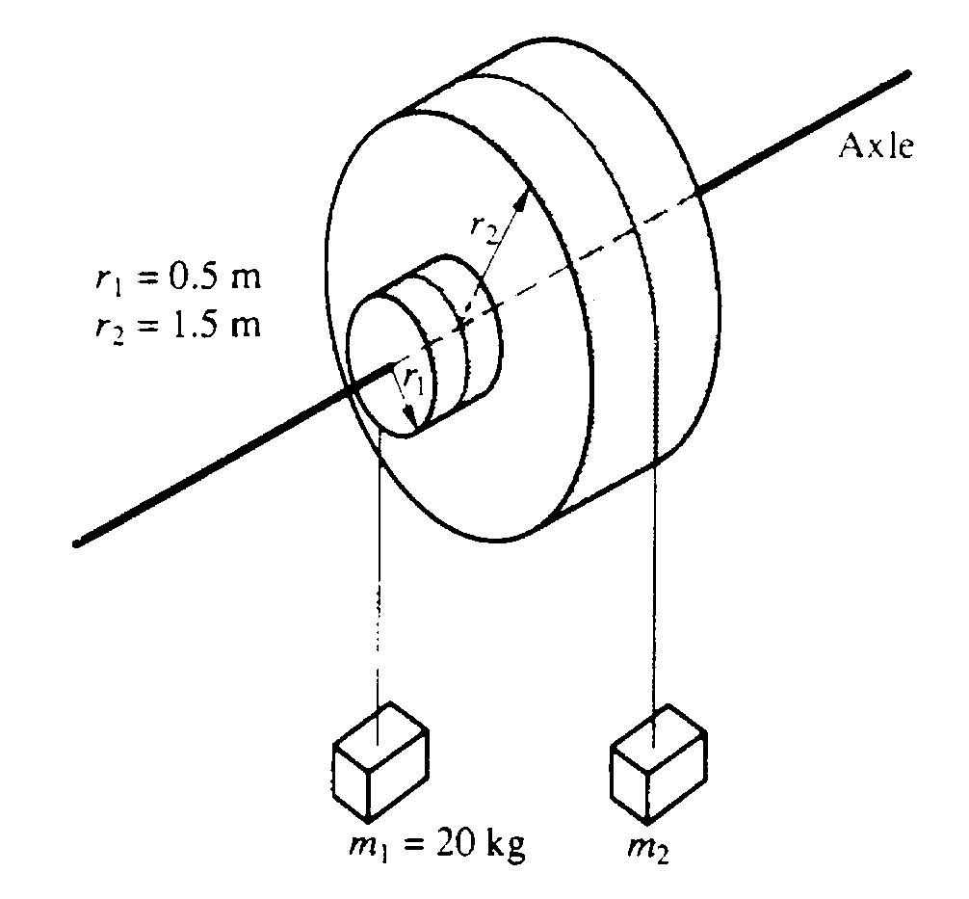
1991M2. Two masses. m₁ and m₂ are connected by light cables to the perimeters of two cylinders of radii r₁ and r₂, respectively. as shown in the diagram above. The cylinders are rigidly connected to each other but are free to rotate without friction on a common axle. The moment of inertia of the pair of cylinders is I = 45 kgm² Also r₁ = 0.5 meter, r₂ = 1.5 meters, and m₁ = 20 kilograms.
a. Determine m₂ such that the system will remain in equilibrium.

The mass m₂ is removed and the system is released from rest.
b. Determine the angular acceleration of the cylinders.
c. Determine the tension in the cable supporting m₁
d. Determine the linear speed of m ₁ at the time it has descended 1.0 meter.
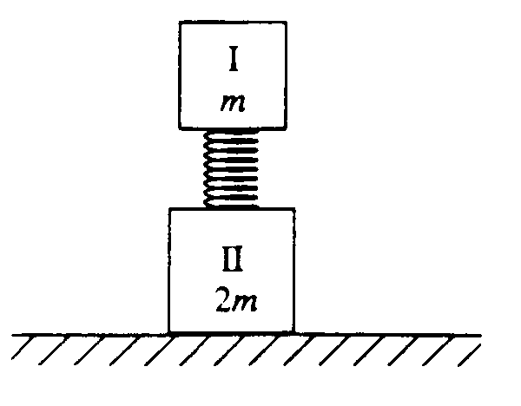
1991M3. The two blocks I and II shown above have masses m and 2m respectively. Block II has an ideal massless spring attached to one side. When block I is placed on the spring as shown. the spring is compressed a distance D at equilibrium. Express your answer to all parts of the question in terms of the given quantities and physical constants.
a. Determine the spring constant of the spring

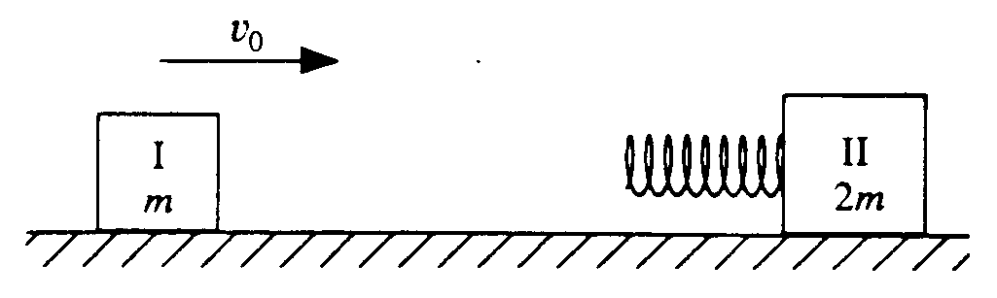
Later the two blocks are on a frictionless, horizontal surface. Block II is stationary and block I approaches with a speed v_{o}, as shown above.
b. The spring compression is a maximum when the blocks have the same velocity. Briefly explain why this is so.
c. Determine the maximum compression of the spring during the collision.
d. Determine the velocity of block II after the collision when block I has again separated from the spring.
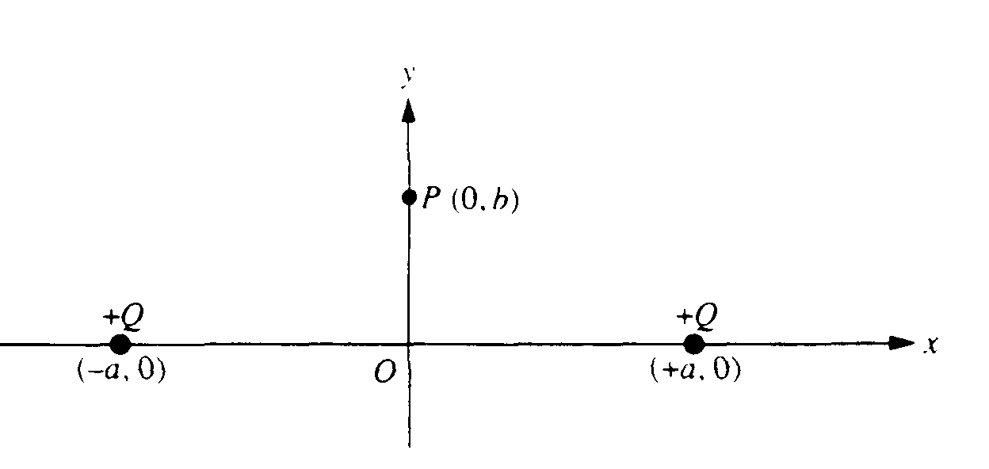
1991E1. Two equal positive charges Q are fixed on the x-axis. one at +a and the other at -a, as shown above. Point P is a point on the y-axis with coordinates (0, b ). Determine each of the following in terms of the given quantities and fundamental constants.
a. The electric field E at the origin O
b. The electric potential V at the origin O.
c. The magnitude of the electric field E at point P.

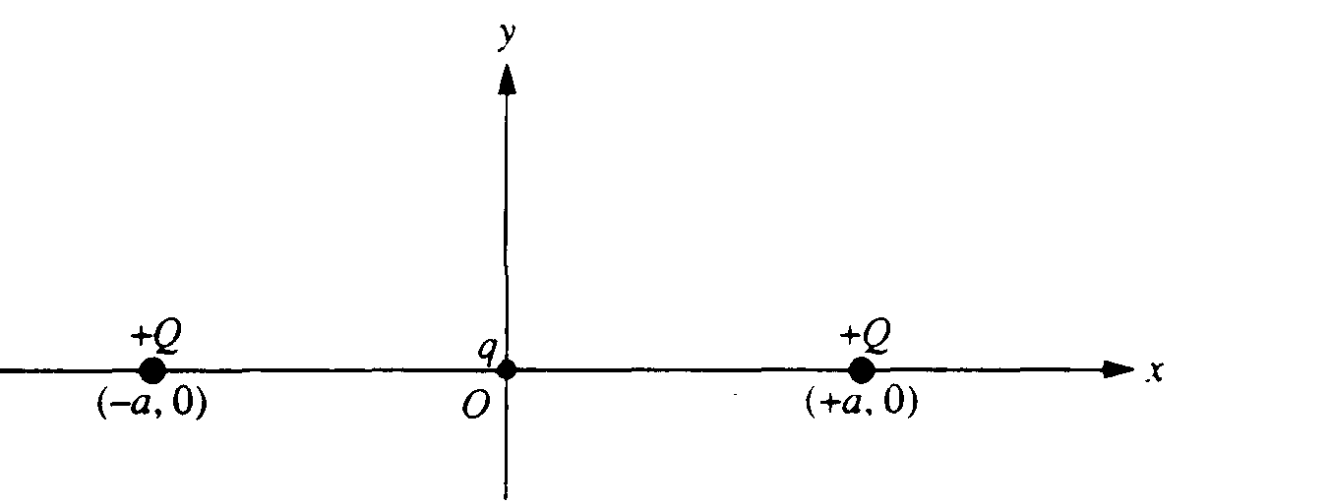
A small particle of charge q (q << Q ) and mass m is placed at the origin, displaced slightly, and then released. Assume that the only subsequent forces acting are the electric forces from the two fixed charges Q. at x = +a and x = -a. and that the particle moves only in the xy -plane. In each of the following cases, describe briefly the motion of the charged particle after it is released. Write an expression for its speed when far away if the resulting force pushes it away from the origin.
d. q is positive and is displaced in the +x direction.
e. q is positive and is displaced in the +y direction.
f. q is negative and is displaced in the +y direction.
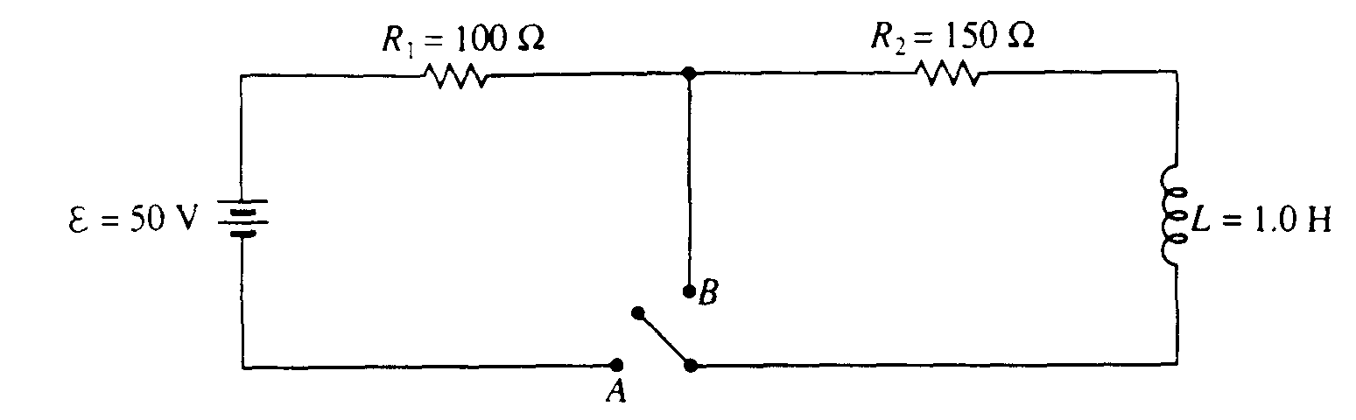
1991E2. In the circuit above. the switch is initially open as shown. At time t = 0, the switch is closed to position A.
a. Determine the current immediately after the switch is closed.
b. Determine the current after a long time when a steady state situation has been reached.
c. On the axes below. sketch a graph of the current versus time after the switch is closed.
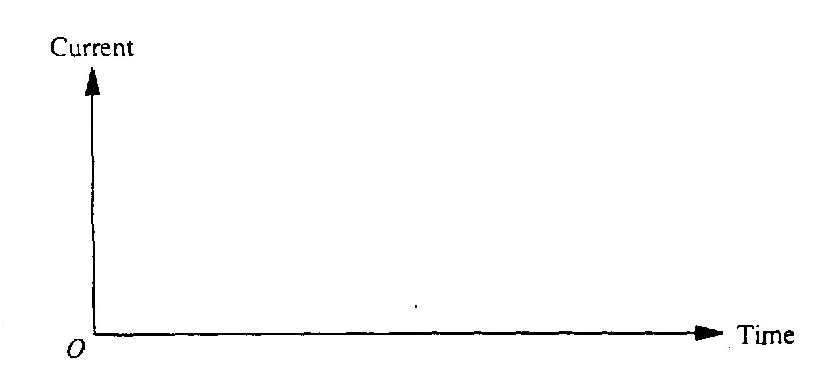

d. Determine the energy stored in the inductor L when the steady state has been reached.

Some time after the steady state situation has been reached. the switch is moved almost instantaneously from position A to position B.
e. Determine the current in the inductor immediately after the position of the switch is changed.
f. Determine the potential difference across the inductor immediately after the position of the switch is changed.
g. What happens to the energy stored in the inductor as calculated in part (d) above?

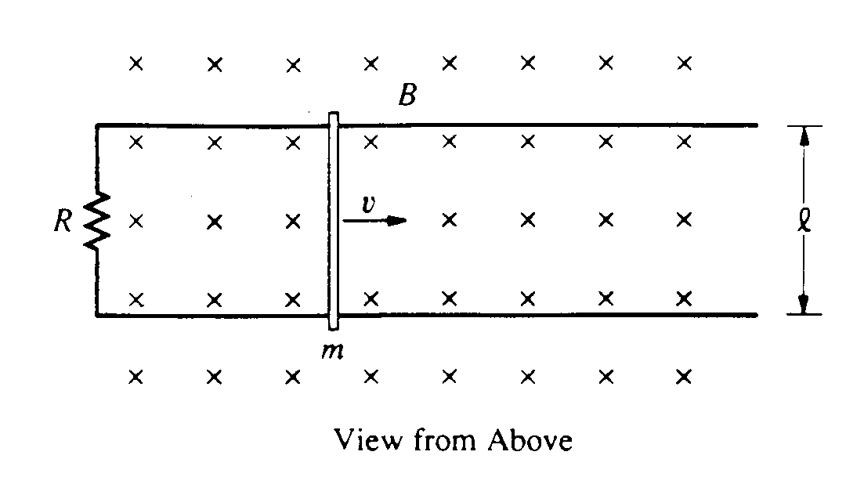
1991E3. A conducting rod is free to move on a pair of horizontal, frictionless conducting rails a distance l apart. The rails are connected at one end so a complete circuit is formed. The rod has a mass m, the resistance of the circuit is R. and there is a uniform magnetic field of magnitude B directed perpendicularly into the plane of the rails, as shown above. The rod and the rails have negligible resistance. At time t = 0, the rod has a speed v_{O} to the right. Determine each of the following in terms of l, m, R, B, and v_{O}

a. The induced voltage in the rod at t = 0
b. The magnitude and the direction of the magnetic force on the rod at t = 0
c. The speed v of the rod as a function of time t
d. The total energy dissipated by the resistor beginning at t = 0

